News Release
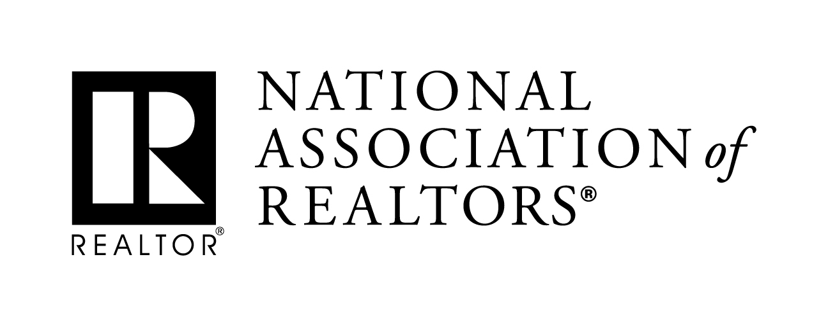 | MEDIA COMMUNICATIONS  For further information contact:  Jon Boughtin, 202-383-1193  jboughtin@realtors.org
Realtors® Claim Victory against Patent Abuse with Settlement
WASHINGTON (September 19, 2016) – The National Association of Realtors® is declaring a major victory against patent abuse in a settlement with Data Distribution Technologies, a subsidiary of the patent enforcement firm General Patent Corporation. DDT sued and threatened several real estate businesses in the past over use of a technology-related patent, but NAR challenged the patent’s validity before the U.S. Patent and Trademark Office and filed a declaratory judgement lawsuit on behalf of NAR members.
NAR’s advocacy on behalf of its membership culminated in a settlement requiring DDT to refrain from enforcing its patent in the real estate industry; the covenant included in the settlement specifically notes that NAR members, associations, MLSs, affiliates, and other related entities are protected from potentially costly litigation.
Tom Salomone, NAR President and broker-owner of Real Estate II Inc. in Coral Springs, Florida, doubled down on the association’s commitment to combating patent abuse and called the settlement a win for Realtors®. “When Realtors® fall victim to abuses in the patent system, NAR is going to have their back,” he said. “We’re hopeful that today’s settlement will remind patent trolls across the country that this type of exploitation is unacceptable and won’t go unanswered.”
DDT claimed their patent, titled “Web-Updated Database With Record Distribution By Email,” covered systems that provide agents and consumers with online searchable real estate databases that can update users via email about new information that comes available on those databases. NAR considered DDT’s patent invalid and enforcement of it an overly broad and thinly-veiled effort to exploit real estate businesses for licensing fees with the threat of high-cost litigation.
Although the settlement marks a victory for NAR, Salomone acknowledged that additional work is required to broadly reform the patent system. “NAR believes in the protection of legitimate intellectual property rights, but we’re ready and willing to invalidate frivolous patent claims aimed at our members,” he Salomone. “To fully defend business owners across the country, however, we need significant reforms to the system that offer robust protections against patent trolls. We’re urging legislators to take a hard look at that in the months ahead.”
NAR has long supported efforts in Congress to make common sense patent litigation reforms that foster innovation and investment while benefiting the whole of the American economy.
-more- #072

Realtors® Claim Victory against Patent Abuse with Settlement – add 1
According to NAR, 2015 saw the most patent disputes in history, with patent trolls composing nearly 67 percent of patent litigation that same year.
The National Association of Realtors®, “The Voice for Real Estate,” is America’s largest trade association, representing 1 million members involved in all aspects of the residential and commercial real estate industries.
# # #
Information about NAR is available at www.realtor.org. This and other news releases are posted in the “News, Blogs and Videos” tab on the website.

