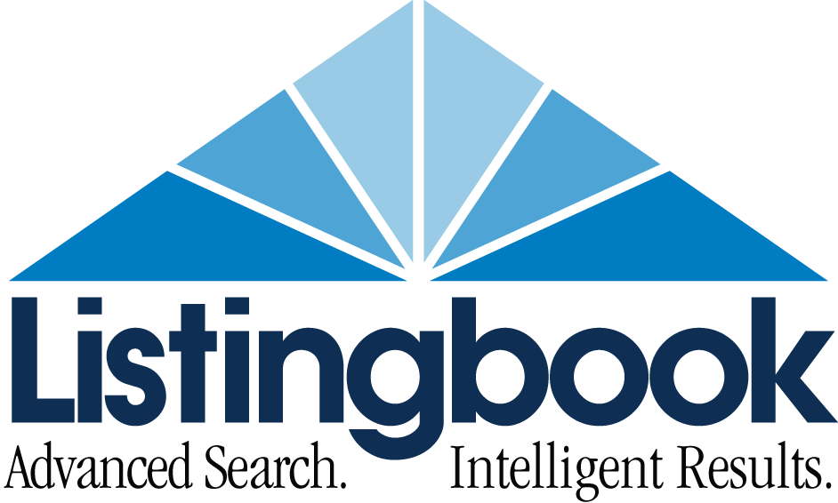

Contact:
Kevin Hawkins
206-866-1220
kevin@wavgroup.com

FACT SHEET

About: Listingbook LLC is the real estate industry’s proven lead nurturing and client servicing platform that allows consumers to “search like an agent.”

Agents: 180,000 +real estate agents have a Listingbook account

Reach: ~60% of REALTORS® nationwide
70+ MLS agreements reaching over 600,000 real estate agents
MLSs reaching 500,000 real estate agents now have access to the new Listingbook platform
2.15 million U.S. consumers have Listingbook accounts
Over 600,000 monthly unique visitors (Feb. 2015, Google Analytics)

Businesses: SaaS (Software as a Service) for agents
Online third-party advertising within Listingbook
Real estate advertising for agents: Featured listings and Open Houses
Brokerage firm partner programs
Lead nurturing business for brokers

Technology: Cloud-based, proprietary infrastructure
Patented “Client Manager” gives agents ability to view client activity and collaborate

Volume: Listingbook agents and brokers have generated an estimated $XX billion in real estate transactions since 2006

Products: Listingbook Basic – Free, limited to managing 3 clients
Listingbook Insight: $14.95 per month, unlimited clients
Listingbook PRO with Mobile: $19.95 per month, all features

Unique offer: Consumers must get a Listingbook account from a real estate agent, free for consumers, as it has richer data from the MLS than IDX, requiring registration to get access so consumers can “search like an agent”

HQ: Greensboro, NC,

Phone: (336) 722-3456
Website: www.listingbook.com
Facebook: https://www.facebook.com/pages/Listingbook/20960637957

